Prevent Heartburn Cancer Campaign

Communication Kit for ASGE Members





American Society for Gastrointestinal Endoscopy, 2018

December 21, 2018

Dear ASGE member:

We invite you to participate in an important public service campaign we are undertaking to raise awareness of the link between chronic heartburn and esophageal cancer. Our goal is to encourage chronic heartburn sufferers to learn more, visit the website [www.PreventHeartburnCancer.org](http://www.PreventHeartburnCancer.org), see a gastroenterologist, or ask their family practitioner or internist for a referral.

What you see below is an ad that is running in airports and on billboards in cities around the country. There are a number of ways you can participate in this campaign, and we have created resources that will make it easy to do so.

These include:

• Content for you to post on your social media channels (personal and those you use for your practice), such as Facebook and LinkedIn

• An infographic featuring important statistics about chronic heartburn and the connection to esophageal cancer. You can post it on your site or social media channels and email it to patients or referring physicians.

• A campaign advertisement that you can post to your site and social media channels and email to patients or referring physicians

• A postcard you may want to print and send to your referring family practitioners/internists, informing them of the campaign and providing a link to the Prevent Heartburn Cancer campaign website

If you have any questions or would like to request a poster of the ad or infographic for your office, please contact Gina Steiner, Director of Communications, at (630) 570-5635 or [gsteiner@asge.org](mailto:gsteiner@asge.org)

Thank you!

Look for this ad in your airport or on a billboard near you!



This ad recently has appeared in airports and on billboards in Washington, DC; Chicago; Cleveland; New Orleans; Houston; and Denver.

**10 SAMPLE SOCIAL MEDIA POSTS**

*NOTE: It is suggested that posts end with a link to the campaign website: “More information is available at www.PreventHeartburnCancer.org.” You can post the ad or infographic as well to boost readership.*

Try combining one of these messages with mention of a holiday, major sporting event or other times when overindulging or stress may make heartburn more noticeable.

1. Are you one of the more than 25 million Americans who experience heartburn daily? Learn about the connection to esophageal cancer and what gastroenterologists can do to prevent disease.

2. Gastroesophageal reflux disease (GERD) is one of the most common digestive disorders in the US. Learn more about the connection between chronic heartburn and esophageal cancer.

3. It’s time to think differently about your chronic heartburn. It can raise your risk of esophageal cancer.

4. Got chronic heartburn? Many people self-medicate without realizing that stomach acid backs up into the esophagus and may lead to more serious disease.

5. Tell your doctor about your heartburn symptoms, their frequency and what you’re taking. Medicine can sometimes mask an underlying condition.

6. What you don’t know about GERD can hurt you. Learn about the connection between chronic heartburn and esophageal cancer.

7. Chronic heartburn can cause precancerous changes in the cells of the esophagus. We can now detect these changes when they are still harmless and cells can be treated or removed.

8. Advances in diagnostic tools enable us to detect precancerous changes in the esophagus when they are still harmless and cells can be removed or treated before they become cancerous.

9. In America, an estimated 25 million people suffer from heartburn symptoms every day. Visit a gastroenterologist to be sure it’s not something more.

10. For many men over age 55, heartburn is something they live with every day. What they don’t know is that it could be linked to esophageal cancer.

**Infographic for Social Media**

Save this image as a picture, and add it to your social media posts and/or your website.

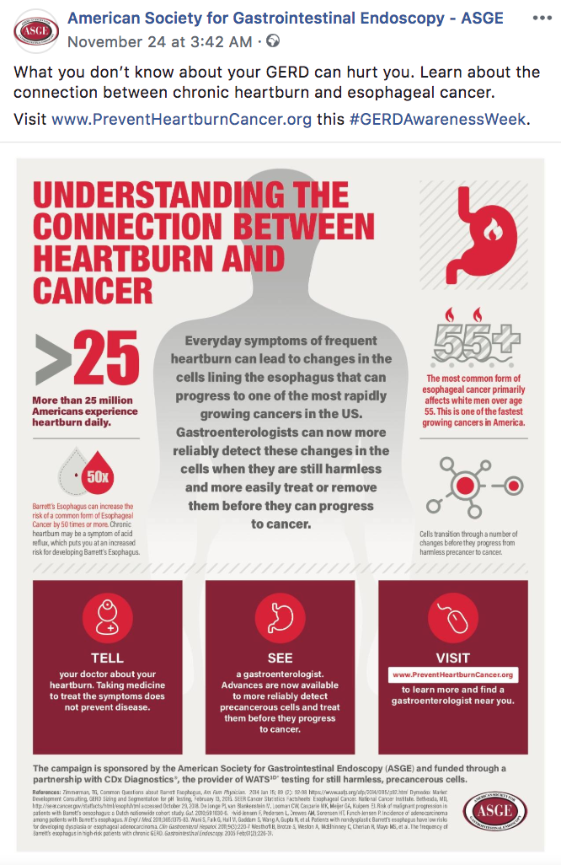

**Postcard**

ASGE has designed a postcard that you can customize and send out to patients or to referring primary care providers.

These front and back images may be sent or taken to a printer, or you can upload them directly to online printing sites. Add the name and address of the recipient, and your office’s contact information, to the back of the postcard.

**Postcard front image**

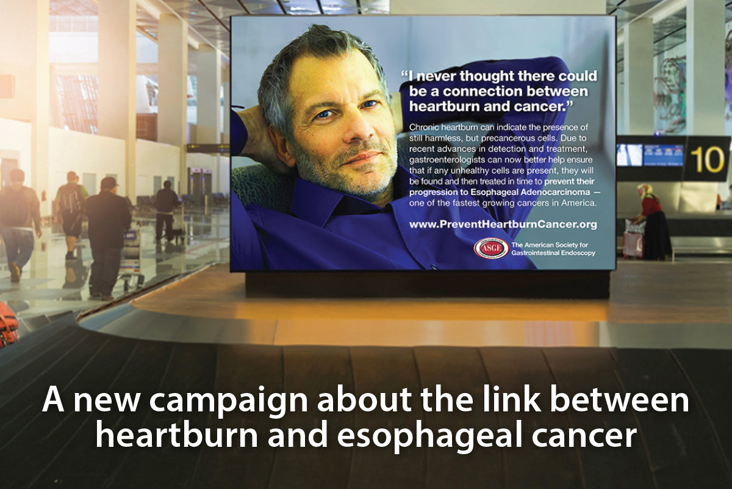

**Postcard back image**

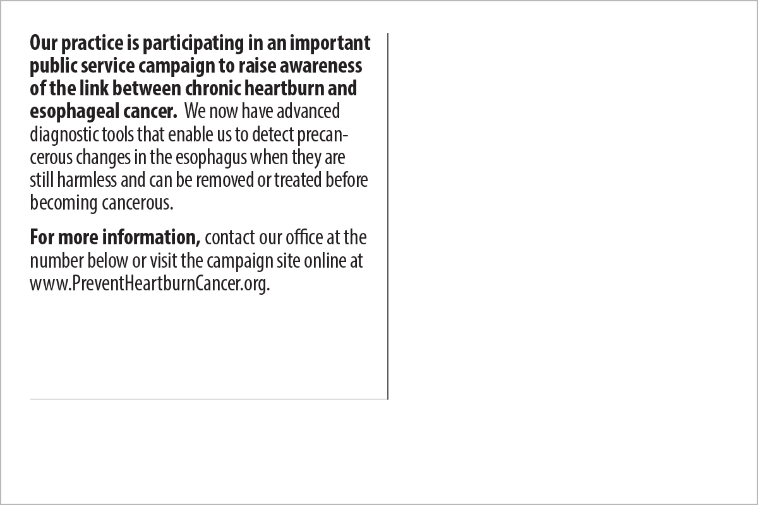

Thank you for helping to spread the word about the link between chronic heartburn and esophageal cancer, and about advances in tools and technologies that allow us to identify and remove/treat precancerous cells in the esophagus.

For more information, visit www.PreventHeartburnCancer.org